



**Placement Empowerment Program**

***Cloud Computing and DevOps Centre***

***A shell script that monitors your log file and alerts you for any error.***

Name: Subiksha R Department:AML



**INTRODUCTION:**

In this proof of concept (PoC), the focus is on creating a shell script that monitors a log file for any errors and alerts the user when they occur. Log files often contain crucial information about system performance and errors, and manually checking them can be time-consuming and inefficient. This script automates the monitoring process by continuously scanning the log file for predefined error patterns or keywords. Upon detecting an error, the script triggers an alert, which could be in the form of an email, system notification, or message to an administrator. The PoC aims to demonstrate how such automation can help system administrators quickly identify and respond to issues, reducing downtime and improving overall system reliability. By leveraging a simple shell script, this approach offers an efficient and lightweight solution for real-time log monitoring and error detection.

**OVERVIEW: Top of FormBottom of Form**

The overview of this proof of concept (PoC) is to develop a shell script that monitors log files for any errors and automatically triggers alerts when issues are detected. Log files are essential for tracking system events, but manually reviewing them for errors can be time-consuming and prone to oversight. This PoC aims to automate the log monitoring process by creating a lightweight and efficient script that continuously checks for specific error patterns or keywords within a log file. Upon detecting an error, the script will send real-time alerts, such as emails or system notifications, to inform administrators or users immediately. The goal is to demonstrate how a simple shell script can be an effective tool for proactive system monitoring, enabling quick responses to potential issues, minimizing downtime, and improving overall system reliability.

**OBJECTIVE:**

1. Automate Error Detection: To create a shell script that continuously monitors log files for predefined error patterns or keywords, reducing the need for manual checking.

2. Real-Time Alerting: To trigger immediate notifications (such as emails or system alerts) whenever an error is detected in the log file, ensuring timely awareness of issues.

3. Improve Response Time: To enable faster troubleshooting and resolution by providing early detection of errors, helping administrators take action promptly.

4. Enhance System Monitoring: To offer a lightweight and efficient solution for continuous log monitoring, improving overall system health and reducing the risk of overlooked issues.

5. Demonstrate Shell Script Capabilities: To showcase the power of shell scripting in automating system tasks like log monitoring and error detection, highlighting its simplicity and effectiveness.

6. Increase System Reliability: To reduce system downtime and failures by providing early alerts for critical issues, allowing for quick intervention before they escalate.

7. Flexible and Customizable: To develop a script that can be easily customized to monitor different log files and error types based on specific system requirements.

**Importance of Setting Up a Local Repository:**Top of Form

1. Proactive Issue Detection

* Early Detection: By continuously monitoring logs, the script helps detect errors as soon as they occur, allowing system administrators to address issues before they escalate into major problems or downtime.

2. Time Efficiency

* Automation of Monitoring: Instead of manually checking logs for errors, the script automates this process, saving valuable time and ensuring that logs are always monitored, even when the system is running without active supervision.

3. Minimized Downtime

* Quick Alerts: Real-time alerts enable administrators to take immediate action when an error is detected, reducing system downtime and maintaining business continuity.

4. Increased System Reliability

* Continuous Monitoring: Automated log monitoring ensures that all errors are captured and addressed in a timely manner, leading to more stable and reliable systems.

5. Improved Troubleshooting

* Instant Notifications: Alerts that are triggered when errors are logged allow administrators to quickly pinpoint problems, reducing the time it takes to troubleshoot and resolve issues.

Bottom of Form

**STEP BY STEP OVERVIEW:**

**STEP 1:**

**Create a log file and save it with .log extension:**

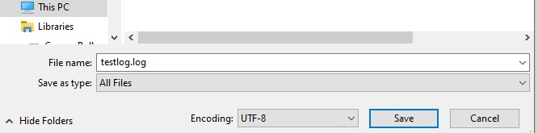

**STEP 2:**

**If it doesn’t exist open a notepad add a script inside it:**

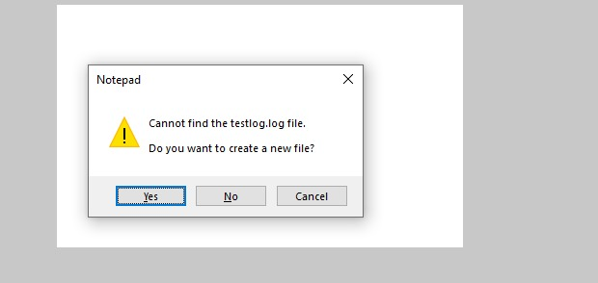

**STEP 3:**

**Add a command to open my directory:**

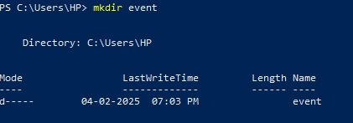

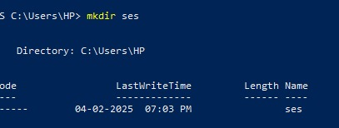



**Step 3:**

**Create a log monitor file:**

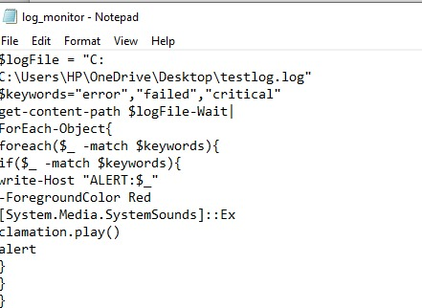

**Step 4:**

**Open the powershell in administrator mode:**

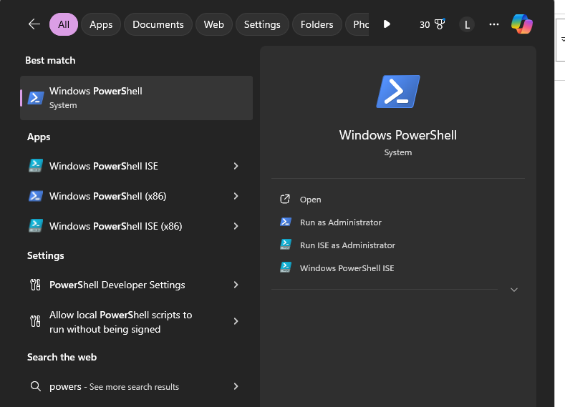

**Click run as administrator to run the commands in that**

**Step 5:**

**Execute a monitor file command there:**



**Expected outcome:**

1. Timely Error Detection: The script will successfully identify errors as soon as they occur in log files, allowing for prompt responses to issues.

2. Real-Time Alerts: The system will trigger immediate notifications (e.g., emails, system alerts) to the appropriate person or team whenever an error is detected, ensuring quick intervention.

3. Reduced System Downtime: By alerting administrators to errors early, the script will help minimize downtime and prevent minor issues from escalating into larger, more disruptive problems.

4. Improved Troubleshooting Efficiency: The script will enhance the ability to diagnose and resolve issues quickly, as alerts provide direct insights into when and where problems occur in the logs.

5. Enhanced System Stability: Continuous log monitoring will lead to a more stable system by ensuring that errors are addressed promptly and the system operates without prolonged failures.

6. Resource Optimization: Administrators will save time and effort by automating the error detection process, freeing up resources to focus on other critical tasks.